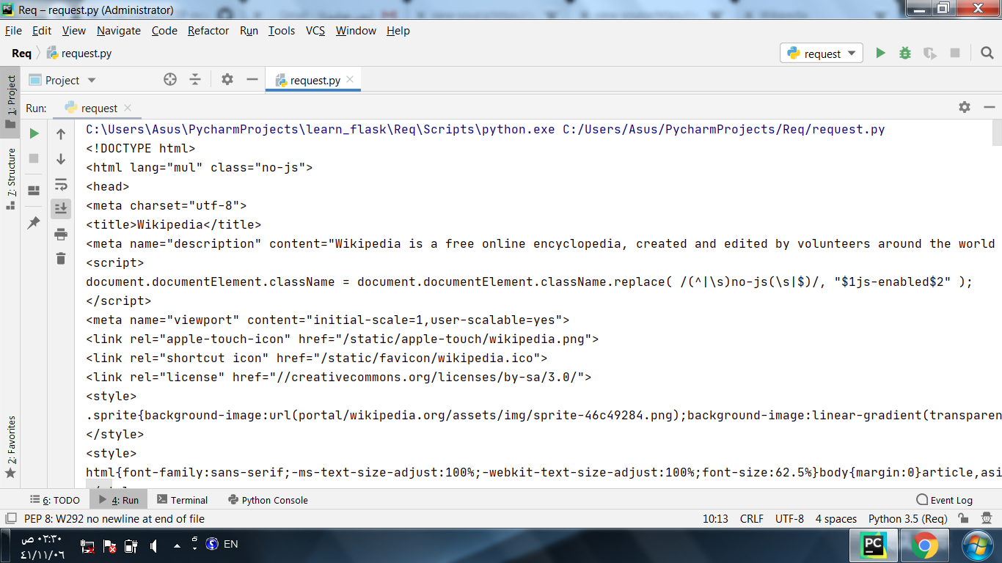***The output of code(HTTP request fetching text data from request.py***